**TCC- Think Cloud Computing: User Portfolio**

**Introduction:**TCC is a game site based on our cloud computing course.  
Our goal is to make a fun site where you can practice cloud computing, see your progress, and climb the leaderboards ladder.  
On our site, you can participate in cloud computing quizzes, where at the end of each quiz you will see information about the correct and incorrect questions.  
In addition, you will be able to access your profile to see your high score, history of games and much more.

**The Target Audience:**

People who are interested in gaining knowledge about cloud computing. This site is meant for beginners to intermediate users, anyone who stops by can find joy in this site.  
This site is for educational purposes only.

**Screen Breakdown:**

**Main Menu Screen**

In the main menu, the user is greeted with our big cloud logo, small information about what you can do on our site, and an option to play a trivia game.  
A navigation bar is displayed at the top of the site, it contains: A login/Register button, a Leaderboard button, an Our Games button and an About Us button.  
When the About Us button is clicked, the user will be redirected to the about us screen.  
When the Our Games button is clicked the user is navigated smoothly to the Our Games section on the same screen.  
When the Leaderboard button is clicked the user is redirected to the Leaderboard screen.  
When the Login/Register button is clicked the user is redirected to the login screen.

Clicking on the top left brain logo will redirect the user to the Main Menu screen.  
  
The Main Menu Screen is a scrollable screen, when scrolling the user will see the Our Games section which can be reached from the navigation bar as mentioned.  
In this section, the user is able to hover the rectangles, each rectangle is a game that the user will be able to play (Note that we implemented the leftmost rectangle that represents the quiz).  
Hovering the quiz game will show information about the game and an option to click “Play Now !” that will redirect the user to the quiz game.  
Upon scrolling, the site’s footer is displayed, where the user is able to see important information about the site such as links to various social media sites, email, address etc.

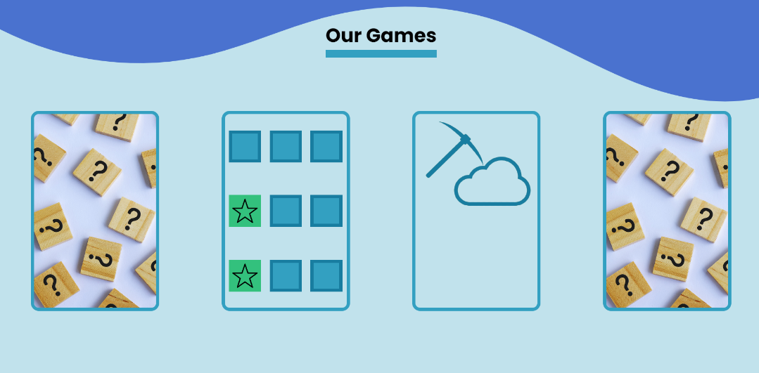

**Login/Register Screen**

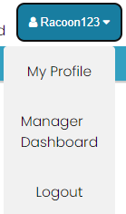In the Login and Register screen the user is greeted with a nice art image, and the navigation bar is accessible just like in the Main Menu Screen.  
If the user already has an account, he can enter his username and password in the corresponding input fields(marked with corresponding placeholders) and press the login button.  
If the Login button is pressed with missing input fields, the action will be cancelled, and a message that asks the user to fill in the field will be displayed.  
If the user fills incorrect username and password combination and clicks the Login button, a red “Incorrect username or password.” message will be displayed underneath the password field.  
If the username and password information is correct, the user will be redirected to the Main Menu screen with the Login/Register button changed to a combobox with the user’s nickname in the placeholder, and upon pressing the combobox the option: My Profile, Manager Dashboard if the user is an admin and a Logout option.  
Clicking on the My Profile button will redirect the user to the My Profile screen.  
Clicking on the Manager dashboard button will redirect the user to his manager dashboard if he is a manager.  
Clicking the Logout button will log the user out of his account and redirect to the Main Menu Screen. If the user doesn’t have an account, the Sign-up button will redirect the user to the Register screen.

**Leaderboard Screen**

In the Leaderboard screen, the navigation bar can be accessed, and this screen is accessible whether the user is logged in or not.  
On this screen, the user can see a chart that displays the users with the highest scores, the top 10 highest scores will be displayed in the chart.

**About us screen:**

In the About Us screen, the navigation bar can be accessed, and this screen is accessible whether the user is logged in or not.  
In this screen general information about the site, our mission, and information about the group of students that developed the site.

**Play Quiz Screen**

If the user is logged in, when he presses the “Play your trivia game” button from the start of the Main Menu screen or the “Play Now !” button in our games section when hovering over the quiz game, he will be redirected to the quiz game. In the quiz game, the navigation bar is accessible, and the user will be displayed the quiz game.  
In the quiz game, the user will have to answer 10 questions, each question will be displayed in the middle of the screen and the 4 answers underneath it. On the left, the user can see his name, his score, and the number of correct answers. Underneath those, the user will have an “Exit” button that when he presses, will leave the game, and return to the Main Menu Screen.  
a progress bar of the answered questions will be displayed underneath the navigation bar, spanning across the whole screen, when after each answered the question the corresponding question bubble will turn on.  
To answer a question, press on one of the 4 options, if the user is correct, the button will turn green, and a popup that will state how much score you gain will show up with a “Next Question” button that when pressed will continue to the next question.  
If the user is wrong a pop up with a “Next Question” button will show and a “Show the correct answer” button that when pressed will show another pop up that displays the correct answer and a “Close” button that will close it.  
when finishing the 10 questions, the “Next Question” button will switch to the “Finish Game” button which will redirect the user to the Statistics Screen.

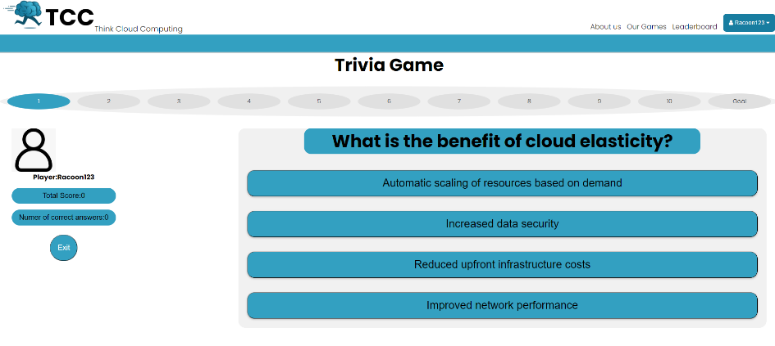

**Game Statistics Screen**

After the quiz is finished, and the user has pressed the “Finish Game” button, the user will be redirected to the Game Statistics screen, in this screen the navigation bar will be accessible, from there he can return to the Main Menu Screen or any other option.  
In the Game Statistics screen, the user will be presented with three graphs:  
The first graph is a Game Bar graph, a circle pie graph that shows the deviation between the correct and incorrect answers, when hovering over each option(Right/Wrong sections in the graph) the user is displayed with an overview of the section.  
The second graph is a Linear Progress graph which displays Linear progress between the questions and the points gained/ not gained. When hovering over each point an overview of the point will be displayed.   
The last graph represents the linear progress of the user over all of his game sessions. The graph itself shows spikes and damps of the user’s score up until the current session.

**

**My Profile Screen**

In the My Profile screen, the user will be able to access the navigation bar just like on the other screens.  
On the screen, 4 input fields will be displayed, a “Username” field, a “Password” field, a “Nickname” field and a “My Highscore” field.   
Each field except the “My Highscore” field will be enabled to change.  
The changes can be saved by pressing the “Save Changes” button.  
When the user scrolls down the screen, a “Match History” section will be available where he can see the history of quizzes he played. Each session will have the game score, correct answers, and the date of the session. In addition to that, each session will contain a “View Statistics” button that when pressed the user will be redirected to the Game Statistics screen of that session.

**Manager Dashboard screen**

This screen, like any other screen, will have the navigation bar accessible.  
On top of that, two buttons will show in the middle of the screen.  
The first button is a “add a question” button, which when pressed the user (admin) will be redirected to the Add Question screen.

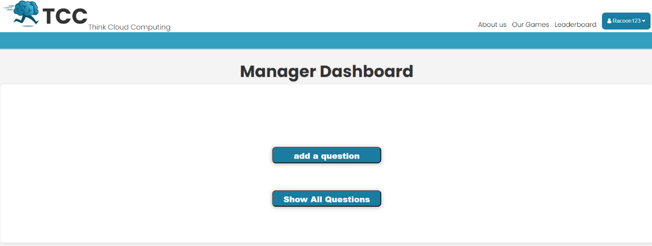 The second button is a “Show all questions” button, which when pressed the user(admin) will be redirected to the Questions screen.

**Add Question screen**

This screen, like any other screen, will have the navigation bar accessible.  
The body of this screen will contain the Question skeleton:  
A text area for the question description, and 4 input areas each labelled as Option 1-4,  
The correct answer, which is one of the 4 options stated, and the difficulty of the Question.  
Upon filling out all of the inputs, and pressing the “Submit” button, the question will be added to the Firebase database and can be drawn out in the pool of questions in the quiz.  
After submission, the user(Admin) will be redirected to the Manager Dashboard screen.

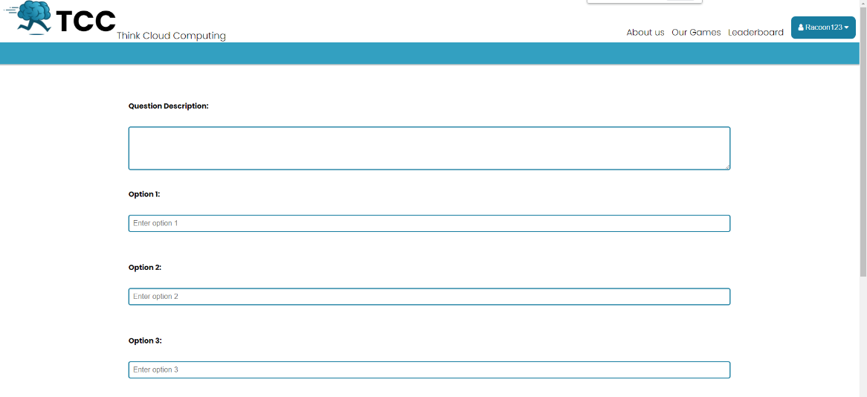

**Questions screen**

This screen, like any other screen, will have the navigation bar accessible.  
This screen will contain every question in the database.  
A questions filter is located at the top of the screen and underneath the navigation bar, this filter allows input for the user(Admin), upon typing, the questions that contain the words that are typed  
will display on the screen, and the questions that do not contain the words that are typed will be removed from the screen.  
Each question can be pressed and when pressing a specific question the user will be redirected to the Update Question screen.

**Update Question screen**

This screen, like any other screen, will have the navigation bar accessible.  
In the body of this screen, the question that is selected in the Questions screen will be set:  
The body contains a text area, where the description of the question is set, the 4 options that the question contains, the correct answer and the difficulty level.  
each input can be altered.  
Underneath the question skeleton, an “Update Question” and a “Delete Question” buttons are available.  
When pressing the “Update Question” button, the question skeleton is checked and verified in the database and the question is saved, and the user(Admin) is redirected to the Manager Dashboard screen.  
the user(Admin) is redirected to the Manager Dashboard screen.

**Register screen**

In the Register screen, the user is greeted with a nice art image, and the navigation bar is accessible just like in the Main Menu Screen.  
The registration process includes filling out the signup form: username, password, nickname, and ID.  
each field is required. After filling out all the fields, the user can press the “Register” button.  
When pressing the button, the backend will validate all the fields, after validation the user will be added to the users collection in the database and he will be redirected to the Main Menu screen and will be logged in.  
**404 screen**

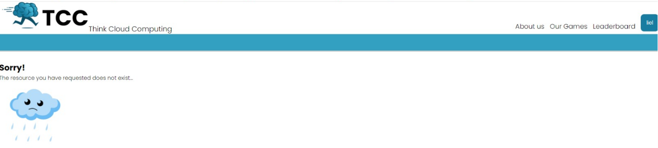The user will be redirected to this screen when a redirection page is missing, or if something went wrong in the process.  
from this screen can go back via the browser, or he can navigate to anything in the navigation bar.

**Optional Errors:**

Some users will try to play the game before logging in, but the game is playable only if the user is logged in, so a guidance message should be displayed when he is trying to press the “Play Game !” button and he is not logged in.  
  
Leaving the game before it is finished does not save the current session.  
If the user exits the game before he finished the game, the session will be lost, a common mistake a user can make is to exit the game and hope to return to the same stage he was in when he left.  
Another common error is that when the user refreshed the quiz it will reset.